STEM AND LEAF
Pearson Edexcel - Tuesday 19 May 2020 - Paper 1 (Non-Calculator) Foundation Tier

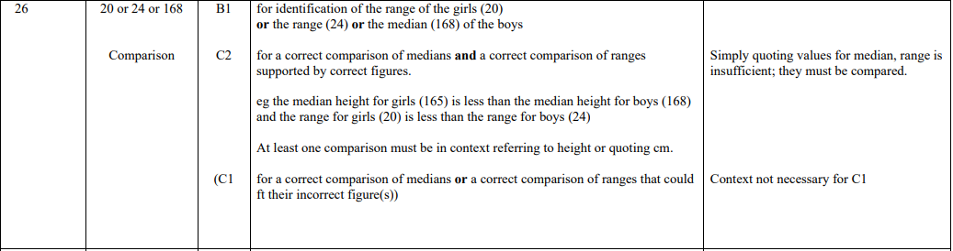

Pearson Edexcel - Tuesday 12 June 2018 - Paper 3 (Calculator) Foundation Tier

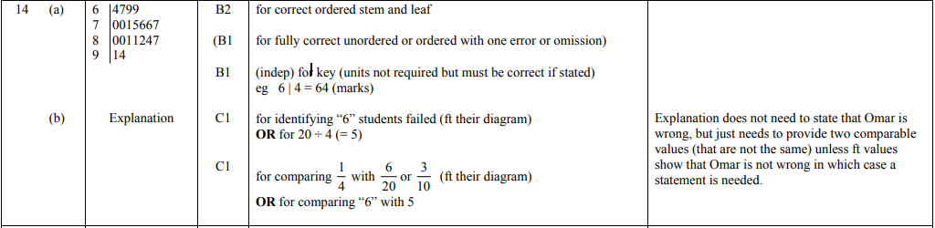

Pearson Edexcel - Thursday 2 November 2017 - Paper 1 (Non-Calculator) Foundation Tier

Pearson Edexcel – Specimen 2 - Paper 3 (Calculator) Foundation Tier

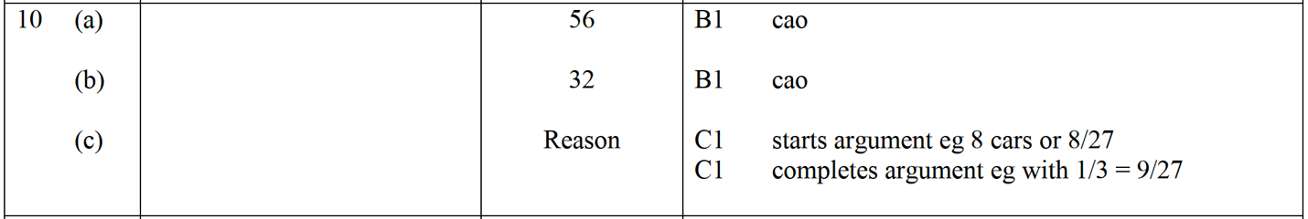

Pearson Edexcel – Specimen 1 - Paper 2 (Calculator) Foundation Tier

